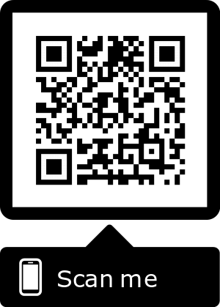
Postdoc Scientific Editing and Reviewing Team (PSERT) Manuscript Submission Sheet

Confidentiality Statement and Mentor Approval

Confidentiality Statement

The Editor-in-Chief and PSERT editors treat every submitted manuscript as a confidential communication. The Editor-in-Chief and editors must exclude themselves from the review of any manuscript that might involve a conflict of interest or the appearance thereof. Therefore, PSERT editors will disclose to the Editor-in-Chief any conflicts of interest that make their knowledge of the information included in the manuscript inappropriate. In addition, the editors pledge not to use knowledge of the work to further their own interests. By signing this agreement, the authors verify that the work to be edited is their own and all other sources have been cited accordingly.

We agree to have the following manuscript reviewed for English usage, punctuation, and organization by a member of the Postdoctoral Scientific Editing and Reviewing Team.

Project Title
Targeted Journal (for author guidelines)
Mentor/PI Name
Department
Signature and Date
Postdoc/ Graduate student Name
Department
Signature and Date

We agree to maintain all components of the above confidentiality statement.

Editor-in-Chief Name
Signature and Date
Postdoc Volunteer Editor
Signature and Date
Postdoc Volunteer Editor
Signature and Date

